# Name:YASH KANJARIYA Sap id: 60009220030

**Branch: Computer Science and Engg(Data Science) Div: D2-3 Course**: **Object Oriented Programming using Java**

Experiment no. 5

**Aim:** To implement class with members and methods (static, non-static, recursive and overloaded methods)

**Problem Statement 1:** WAP to find value of y using recursive function, where y=x^n

**Code:** shubhjyot@Shubhjyots-MacBook-Pro 60009220197_D107 % cat Recursive.java

import java.util.*; public class Recursive {

public static int calcPower(int base,int power){ if(power==0)

return 1; if(base==0) return 0; else

return base*calcPower(base,power-1);

}

public static void main(String[] args) { Scanner sc=new Scanner(System.in);

System.out.println("Enter a number and its power"); int x=sc.nextInt();

int n=sc.nextInt(); int y=calcPower(x,n);

System.out.println("y = "+y);

}

}

# Output:

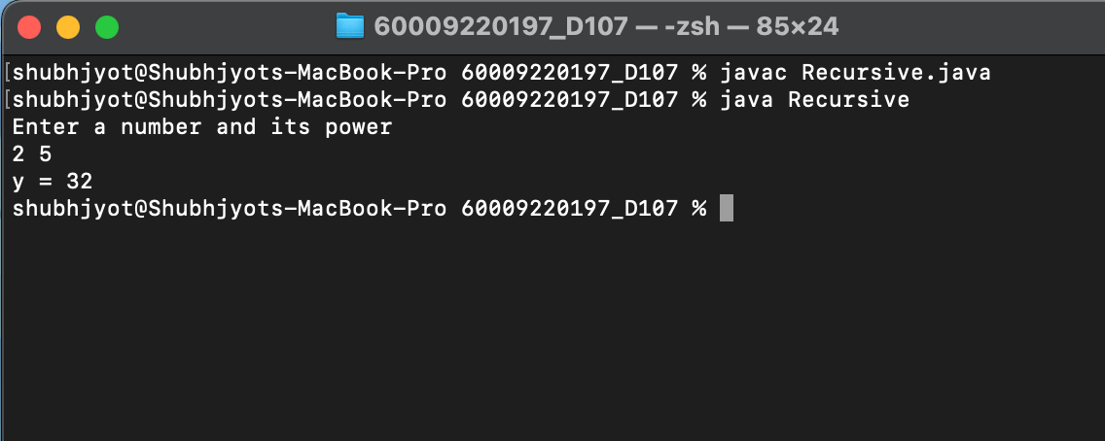

**Problem Statement 2:** WAP to display area of square and rectangle using the concept of *overloaded*

functions.

**Code:** shubhjyot@Shubhjyots-MacBook-Pro 60009220197_D107 % cat Overloaded.java

import java.util.*;

import javax.lang.model.util.ElementScanner14; class Overloaded {

static float area(float s)

{

return(s*s);

}

static float area(float l,float b)

{

return(l*b);

}

");

public static void main(String parms[]) { int choice;

float n1,n2;

Scanner sc=new Scanner(System.in); System.out.println("1.Square\n2.Rectangle\nEnter your choice:

choice=sc.nextInt(); if(choice==1)

{

System.out.println("Enter the side length "); n1=sc.nextFloat(); System.out.println("Area="+area(n1));

}

else if(choice==2)

{

System.out.println("Enter the length and breadth"); n1=sc.nextFloat();

n2=sc.nextFloat(); System.out.println("Area="+ area(n1,n2));

}

else

System.out.println("Invalid choice");

}

}

# Output:

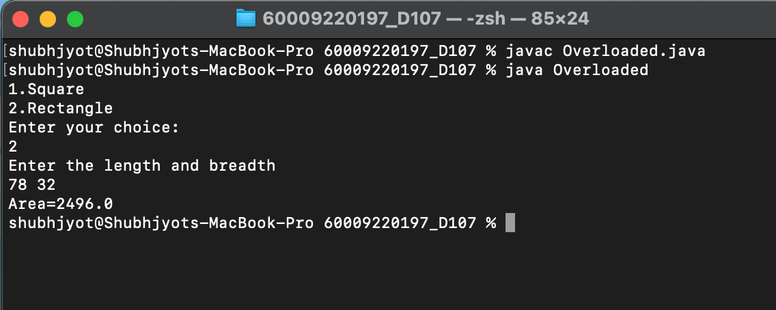

**Problem Statement 3:** WAP to perform mathematical operations on 2 complex numbers by passing and returning object as argument.

**Code:** shubhjyot@Shubhjyots-MacBook-Pro 60009220197_D107 % cat Complex.java

import java.util.*; class Complex {

float r,i;

Complex add(Complex c2)

{

Complex c3=new Complex(); c3.r=r+c2.r; c3.i=i+c2.i;

return c3;

}

Complex sub(Complex c2)

{

Complex c4=new Complex(); c4.r=r-c2.r;

c4.i=i-c2.i; return c4;

}

void display()

{

System.out.println(r+"+i("+i+")");

}

public static void main(String parms[]) { int choice;

Scanner sc=new Scanner(System.in); Complex c1=new Complex();

System.out.println("Enter real and imaginary parts of first complex number: ");

c1.r = sc.nextFloat(); c1.i = sc.nextFloat(); Complex c2=new Complex();

System.out.println("Enter real and imaginary parts of second complex number: ");

c2.r = sc.nextFloat(); c2.i=sc.nextFloat();

System.out.println("1.Add\n2.Sub\nEnter your choice:"); choice = sc.nextInt();

if(choice == 1)

{

Complex sum=c1.add(c2); System.out.print("Sum is:"); sum.display();

}

else if(choice == 2)

{

Complex diff = c1.sub(c2); System.out.print("Difference is: "); diff.display();

}

else

System.out.println("Invalid choice");

}

}

# Output:

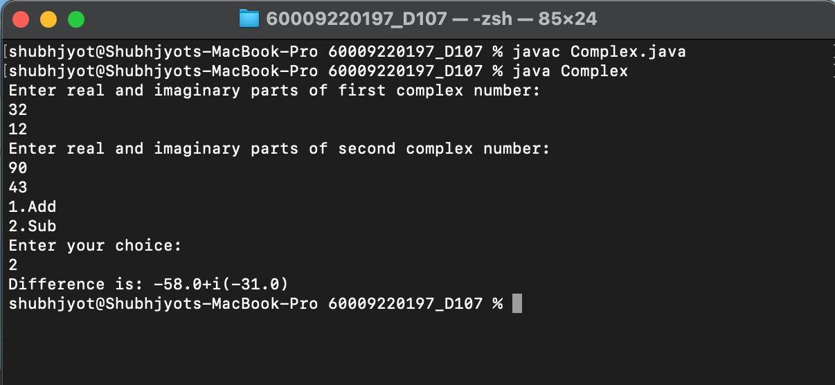

**Problem Statement 4**: WAP to count the number of objects made of a particular class using static variable and static method to display the same.

**Code:** shubhjyot@Shubhjyots-MacBook-Pro 60009220197_D107 % cat CountObject.java

import java.util.*; public class CountObject {

static int count=0; public CountObject(){

count++;

}

static void display(){

System.out.println("The number of objects are: "+count);

}

public static void main(String[] args) { CountObject obj1= new CountObject(); display();

CountObject obj2=new CountObject(); display();

CountObject obj3=new CountObject(); display();

}

}

# Output:

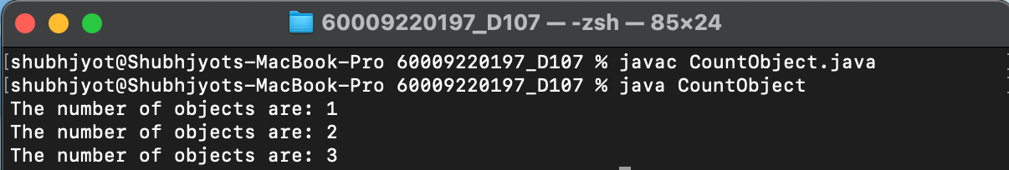

**Problem Statement 5:** WOOP to arrange the names of students in descending order of their total marks, input data consists of students details such as names, ID.no, marks of maths, physics, chemistry. (Use array of objects)

**Code:** shubhjyot@Shubhjyots-MacBook-Pro 60009220197_D107 % cat ArrayObjects.java

import java.util.*;

public class ArrayObjects {

public static void main(String[] args) { Scanner sc=new Scanner(System.in);

System.out.println("Enter the number of Students: "); int n=sc.nextInt();

Student temp=new Student(); Student[] s=new Student[n]; for(int i=0;i<n;i++){

s[i]=new Student();

}

for(int i=0;i<n;i++){ System.out.println("Enter name: "); s[i].name=sc.next(); System.out.print("Enter roll no: "); s[i].roll = sc.nextInt();

System.out.print("Enter marks scored in physics,chem and

maths: ");

}

s[i].p = sc.nextInt();

s[i].c = sc.nextInt();

s[i].math = sc.nextInt();

s[i].total = s[i].p + s[i].c + s[i].math;

for(int i=1;i<n;i++){ if(s[i].total>s[i-1].total){

temp = s[i]; s[i] = s[i-1]; s[i-1] = temp;

}

}

System.out.println("Name\tRoll\tPhy\tChem\tMaths\ttotal"); for(int i = 0; i<n; i++){

System.out.println(s[i].name + "\t" + s[i].roll + "\t" + s[i].p

+ "\t" + s[i].c + "\t" + s[i].math + "\t" + s[i].total);

}

}

}

class Student{ String name;

int roll,p,c,math,total;

}

# Output:

